Competency Project

Yadan Liu

CIS 241

12/08/2022

This website includes Home, Resume, Interest, Guestbook and Reflections.

Home Page

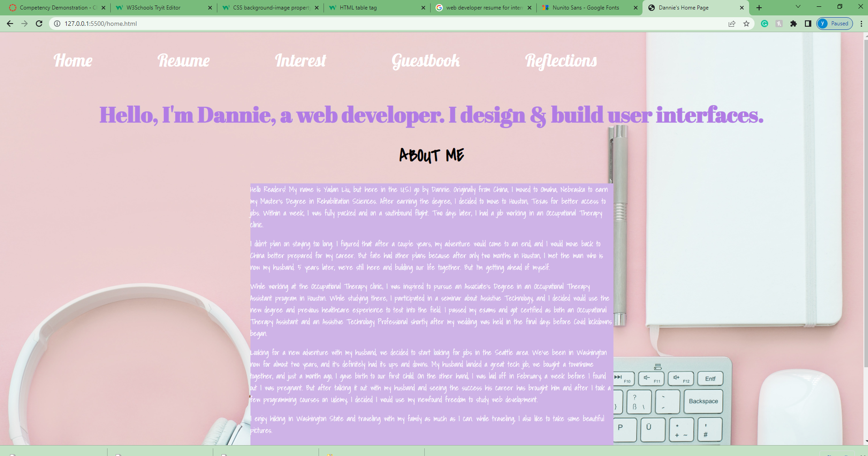



Features:

In the navigation bar on the top, you can click on each text to different pages.

In the footer, you can click on LinkedIn image to access my LinkedIn profile.

Resume Page

Features:

If you hover on each row, it will highlight the whole row to be light purple.

Interest Page

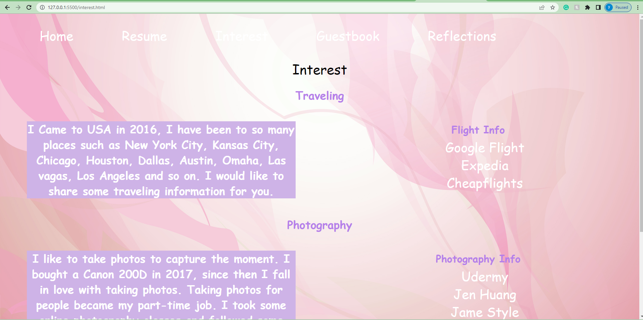

Features:

On the right side, there are six different hyperlinks that you can click on.

Guestbook

Features:

This is a web form, and you can type your name, click on drop-down options, your website info and comment. To submit the form, you can click on the button “ sign my guestbook”.

Features:

You can read my reflection on this semester.

In the footer, you can click on LinkedIn image to access my LinkedIn profile.